EM Pro simulation

Ha Tran, 19/2/2017

# EM Pro overview

* EM Pro workshop provide information about EM wave solver
* MoM: only available in ADS, use to calculate planner geometry line microstrip line
* FEM and FDTD: available in EM Pro. Both can be used to simulate arbitrary 3D geometries.
* We choose FEM over FDTD because
  + N-port network (S-parameter) simulations in FEM is faster than FDTD
  + Frequency scaling is possible
  + Our Graph/Data has frequency as x-axis. There is no need to do IFFT to have a graph like in case of FDTD

|  |  |  |  |
| --- | --- | --- | --- |
|  | **MoM** | **FEM** | **FDTD** |
| **Domain** | Frequency | Frequency | Time |
| **Software** | ADS/EM Pro | ADS/EM Pro | ADS |
| **Geometry** | Planner, Multi-layer | Arbitrary 3D geometries: antenna, waveguide | |
| **Application** | Microstrip line | Filter, resonator | TDR |

Table 1: Comparison table, MoM, FEM and FDTD

Figure 1: Simulation flow in EM Pro

# Rectangular WG section (without SMA to WG adapter)

WR 90 Waveguide Straight Section

* + Length = 3 (inches) = 0.0762 (m)
  + WR90 cross section = 0.9x0.4 (square inches)
  + Cut off frequency = 6.56 GHz
  + Perfect electric conductor (PEC)

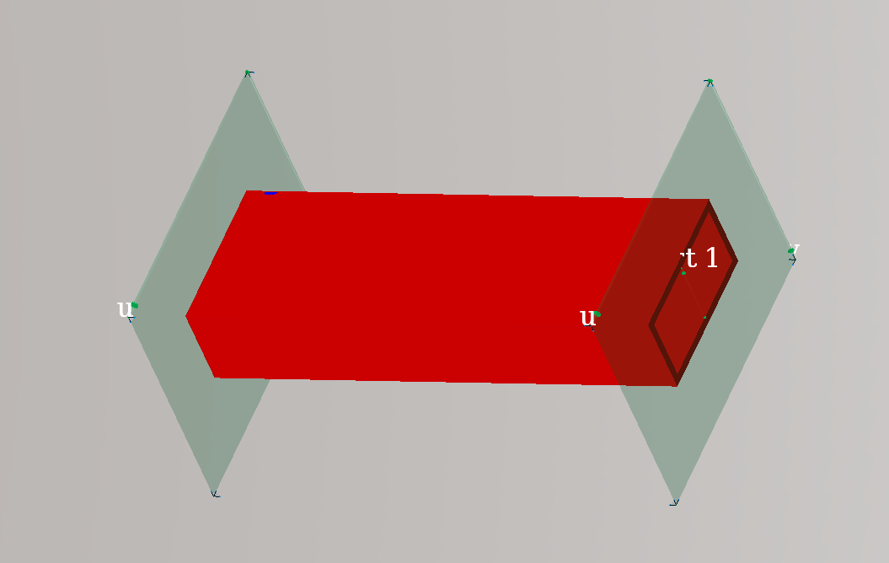

Figure 2: 3 inches WR90 waveguide section

## Propagation Constant

* Because we use PEC, there is no attenuation in the waveguide:



* Phase constant beta can be written in term of the cut off frequency as:

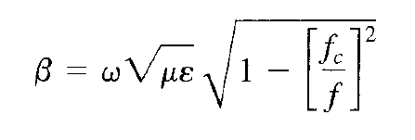

* EM Pro can give us the propagation constant vs frequency graph

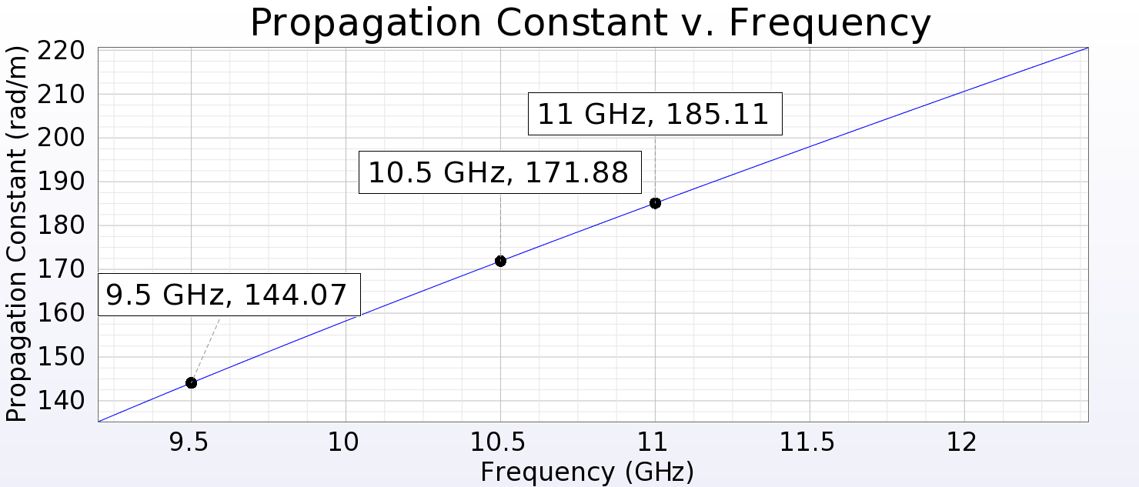

Figure 3: Propagation constant vs Frequency form EM Pro

|  |  |  |  |
| --- | --- | --- | --- |
| **Frequency (GHz)** | **EM Pro** | **Theory** | **Difference** |
| 9.5 | 144.07 | 143.91 | 0.11% |
| 10.5 | 171.88 | 171.71 | 0.10% |
| 11 | 185.11 | 184.93 | 0.10% |

Table 2: Propagation constant, EM Pro vs Theory

## Impedance

* Impedance of TE and TM mode wave:

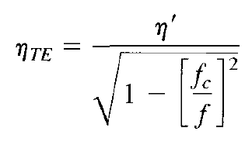 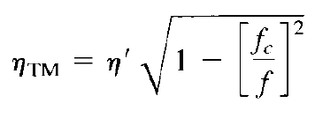

* Impedance from EM Pro:

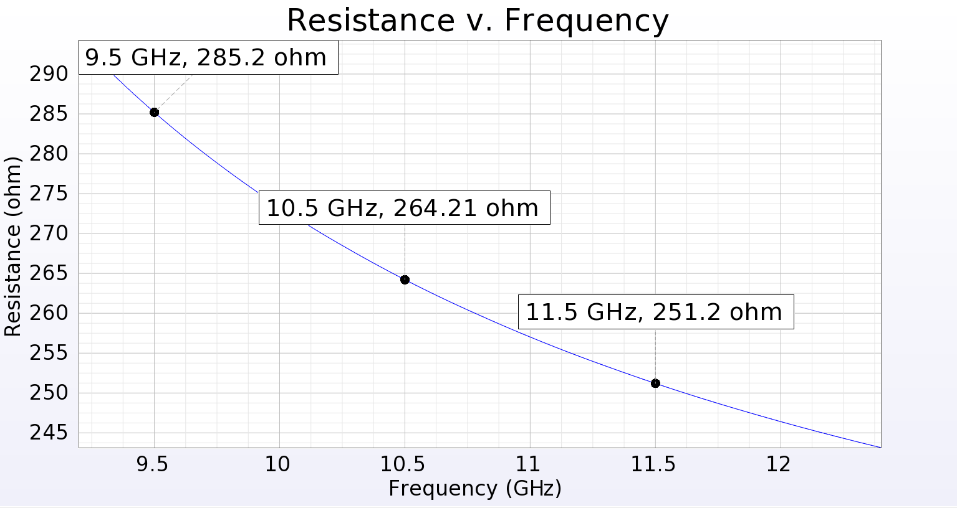

Figure 4: Impedance vs Frequency from EM Pro (imaginary part = 0)

|  |  |  |  |
| --- | --- | --- | --- |
| **Frequency (GHz)** | **EM Pro** | **Theory (TM)** | **Theory (TE)** |
| 9.5 | 285.2 | 285 | 495 |
| 10.5 | 264.21 | 295.36 | 481.2 |
| 11.5 | 251.2 | 309.64 | 459.1 |

Table 3: Impedance from EM Pro vs Theory

**NOTE:** We have a huge different between simulation and calculation.

* See how they derived impedance for TM and TE mode in textbook
* See how to identify which mode is dominant
* One option is to see a 3-D view of the E-field
* The other option is to run multimode simulation

## S-parameter

* With proper waveguide port setup, EM Pro can give us directly S12 (S21) and S11
* In the sample (no sample in the holder), S11=0, |S21| = 1, angle(S21) = beta*d
* The data from simulation is tested with Thanh’s code (result in her report)

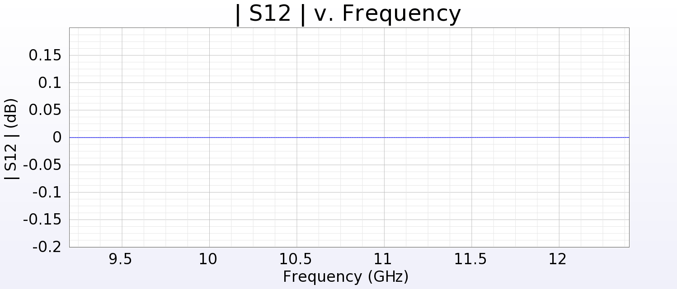

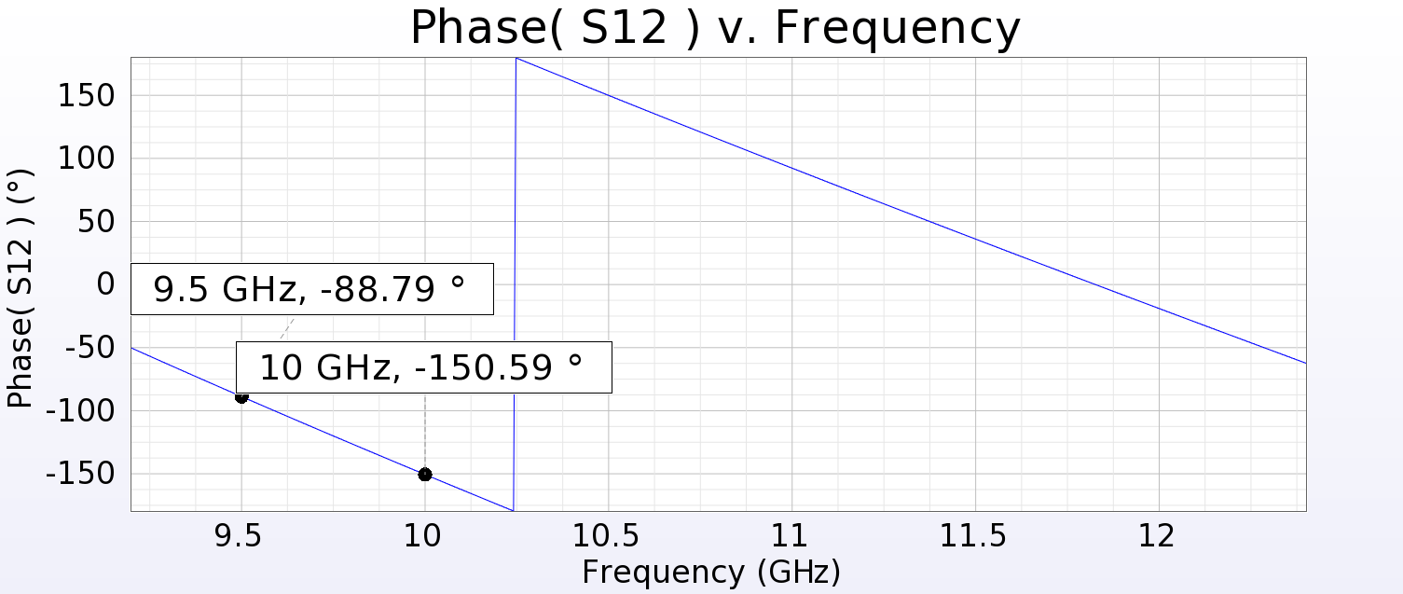

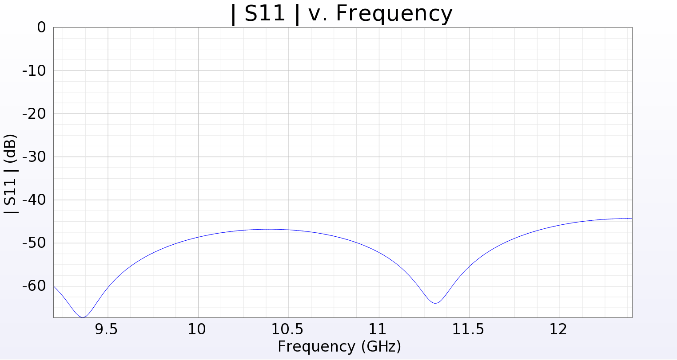

## E-field in 3D graph

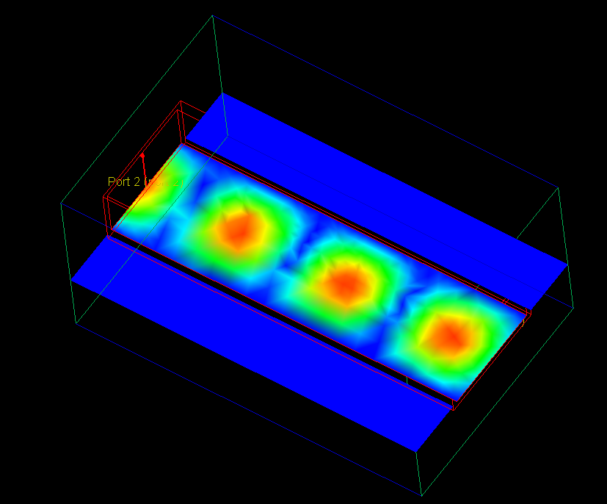

Figure 5: 3D view of E-field

Number of cycles = Length / phase constant does not match with what in the picture

# Horn antenna

* See dimensions in appendix
* WR90 standard waveguide horn antenna 15dBi gain

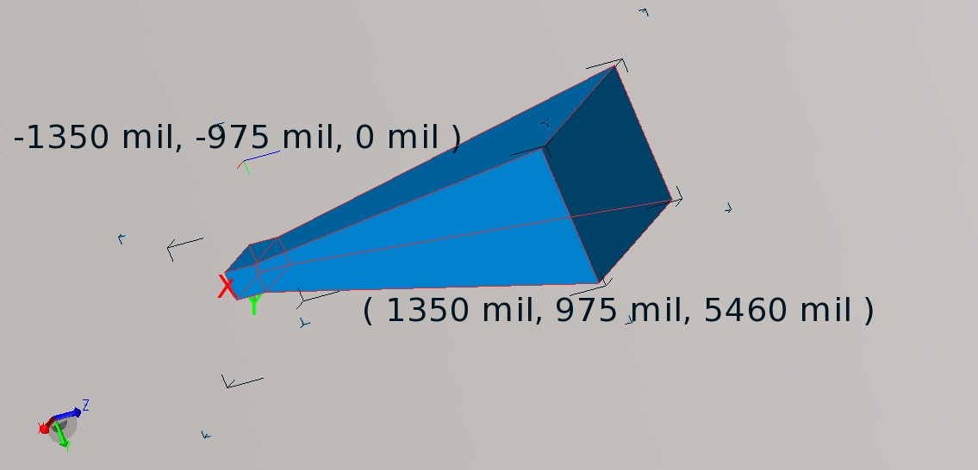

Figure 6: WR90 waveguide horn antenna

## S11

* Again, we can get S11 quickly by defining a waveguide port

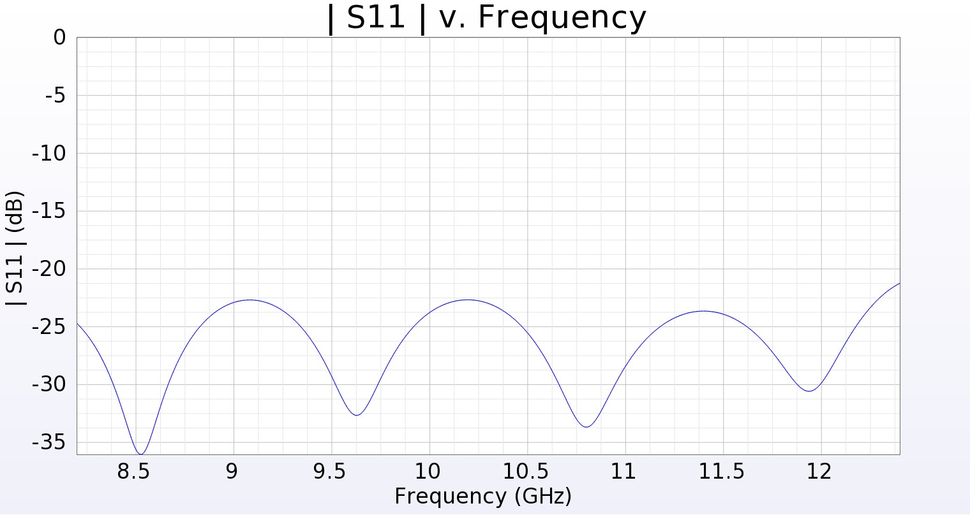

## Gain

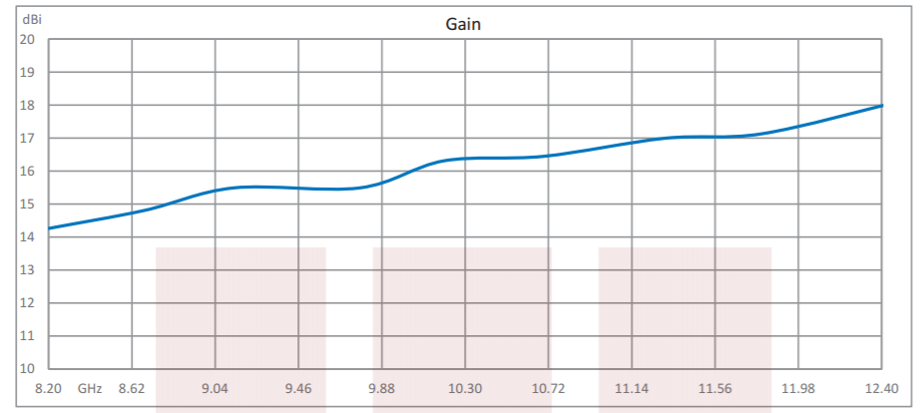

Figure 7: 15dBi horn antenna datasheet

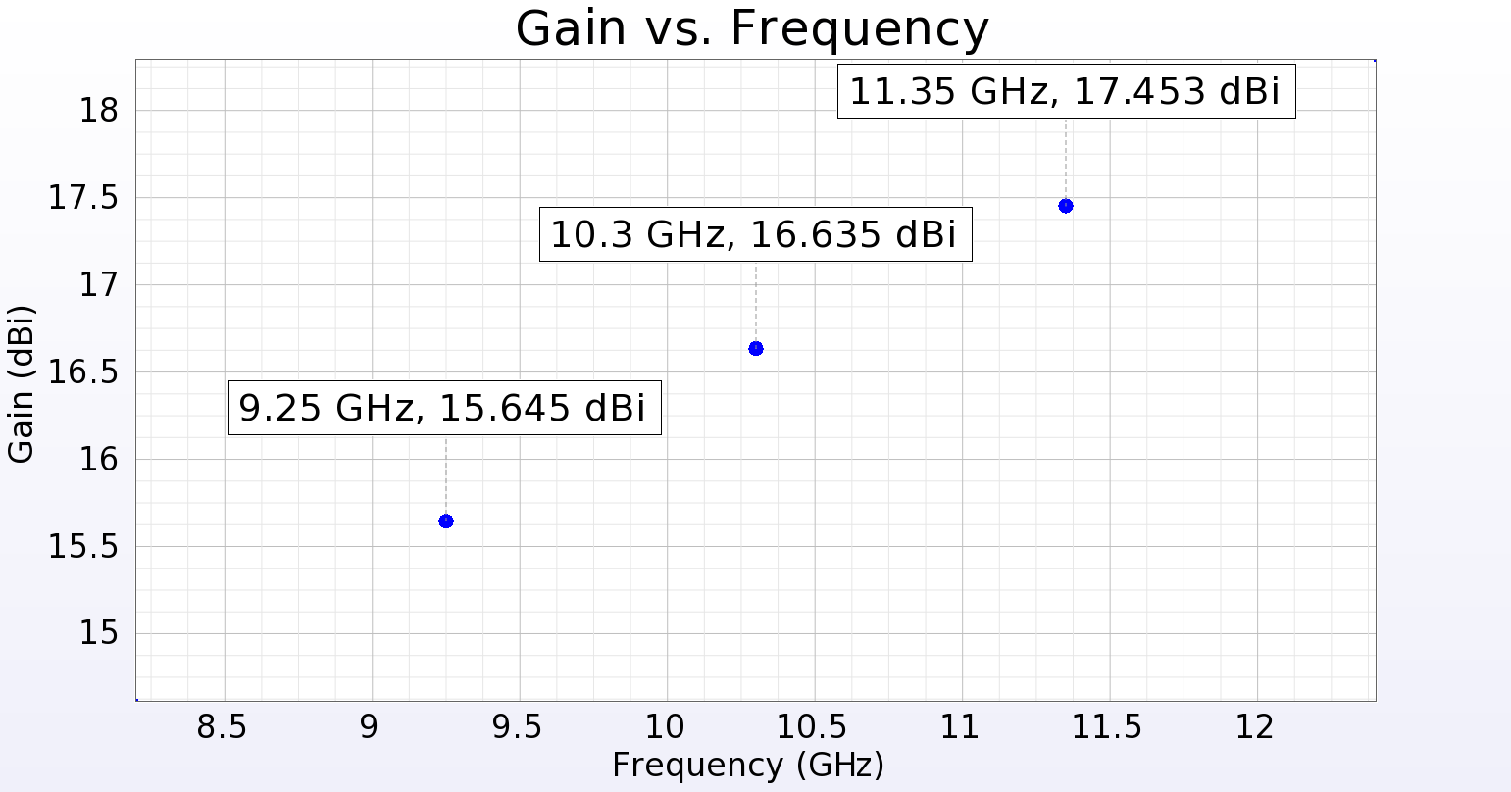

Figure 8: Horn Antenna Gain from EM Pro

|  |  |  |  |
| --- | --- | --- | --- |
| **Frequency (GHz)** | **EM Pro (dBi)** | **Datasheet(dBi)** | **Different(dB)** |
| 9.25 | 15.645 | 15.5 | 0.145 |
| 10.3 | 16.635 | 16.4 | 0.235 |
| 11.35 | 17.453 | 17 | 0.453 |

Table 4: Horn Antenna Gain Simulation vs Datasheet

Note: I keep receiving an error (see below). Higher frequency = Higher percent (7.47). That may be the reason why we have higher error at high frequency

WARNING: Computed radiated power exceeds the available power by 7.47 percent at 8.9000 GHz for excitation 1.

Either decrease the Initial Target Mesh Size on the Mesh/Convergence Properties Advanced tab,

Or move the radiation boundary farther away from the radiating elements.

## Beam pattern, E-field

A plot of E-field or H-field can be generated from EM Pro.

Missing mean of validating the results

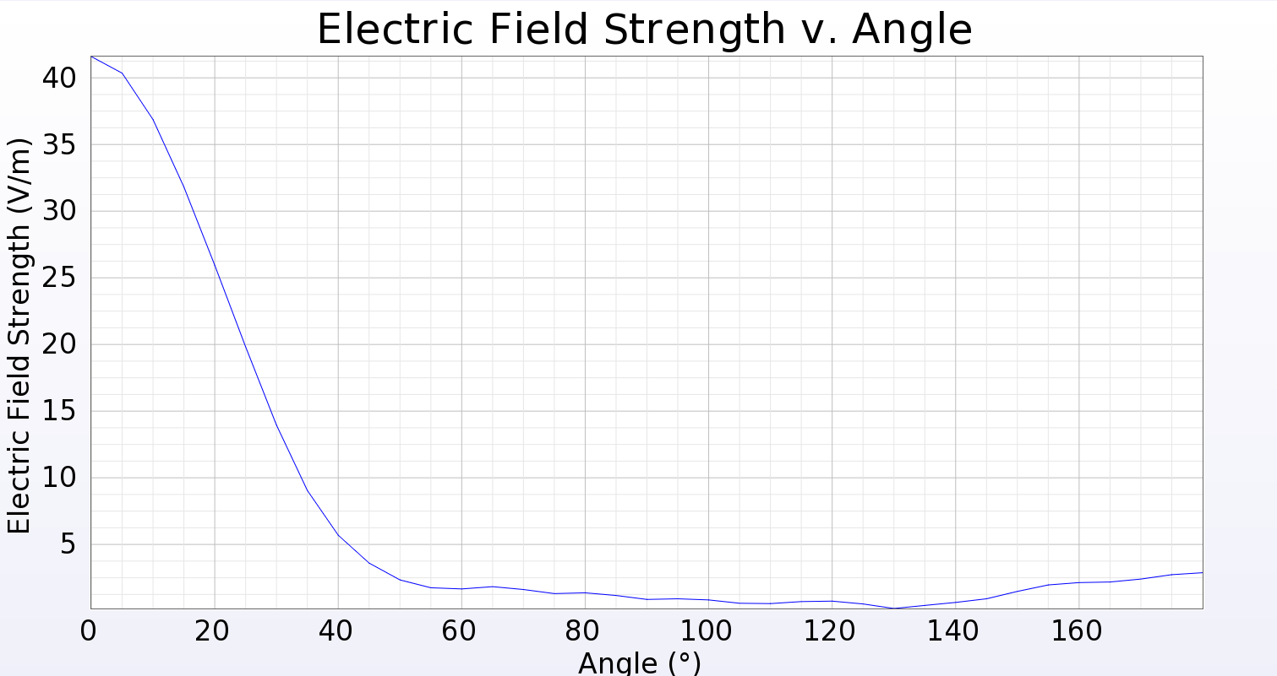

Figure : E-field of horn antenna

# APPENDIX

Waveguide dimension: http://www.atmmicrowave.com/tech-notes/rectangular-waveguide-information/

Waveguide equations: E-mag textbook chapter

Antenna dimensions: https://www.fairviewmicrowave.com/images/productPDF/SH190-15.pdf

EM Pro workshop: <http://www.keysight.com/upload/cmc_upload/All/EMPro_Workshop_4.0.pdf?&cc=US&lc=eng>

